**Execute-MSI and Uninstall-ADTApplication**

**Installation:**

● Execute-MSI: This cmdlet is used to execute MSI files.

You can specify the path to the MSI file and various parameters like -Action Install, -Path, and -DeployMode (Interactive, Silent, NonInteractive).

● Example: Execute-MSI -Action Install -Path "C:\path\to\your.msi" -DeployMode Silent

**Uninstallation (via PowerShell):**

1. **Uninstall-ADTApplication**  
   → Uninstalls apps installed with **PSAppDeployToolkit**.
2. **Execute-MSI -Action Uninstall -Path "{GUID}"**  
   → Uses product **GUID** to uninstall via MSI.
3. **Start-Process with msiexec.exe**  
   → Directly calls Windows Installer to uninstall.  
   → Example:

Start-Process -FilePath "msiexec.exe" -ArgumentList "/x{GUID} /qn" -Wait

All methods support **silent uninstall** using /qn.  
Use **product GUID** to target the specific installed app.

**Other related commands:**

● **Get-RunningProcesses**: Checks for running processes that might need to be closed before an installation or uninstallation

● **Show-WelcomePrompt**: Displays a welcome prompt to the user.

● **Remove-MSIApplications**: Removes specified MSI applications.

● **Unblock-ADTAppExecution**: Unblocks the execution of an application that was blocked.

● **Unregister-ADTDll** : Unregisters a specific DLL.

**Execute-MSI in PSAppDeployToolkit**

* **Purpose:-** Used to install, uninstall, patch, or repair MSI/MSP files using msiexec.exe switches.
* **Installation:**
* **Basic Command: Execute-MSI -Action Install -Path "C:\path\to\app.msi"**

**Common Parameters:**

* **/qn – Silent install**
* **REBOOT=ReallySuppress – Prevent reboot**
* **/L*v – Verbose logging**

**Example:** Execute-MSI -Action Install -Path "app.msi" -Parameters "/qn REBOOT=ReallySuppress"

* **Uninstallation:**
* **Basic Command:**
* **Execute-MSI -Action Uninstall -Path "C:\path\to\app.msi"**
* **Alternative: Use product GUID instead of MSI path.**
* **Same parameters apply (/qn, REBOOT=ReallySuppress, /L*v).**

**Important Options:**

* **Product Code Support: Can uninstall using product GUID.**
* **Log Output: Use -LogName to save logs.**
* **Skip Reinstall Check: Use -SkipMSIAlreadyInstalledCheck.**
* **Error Control: Use -ContinueOnError to allow script to continue after failure.**

**Practical Implementation of the installation command:**

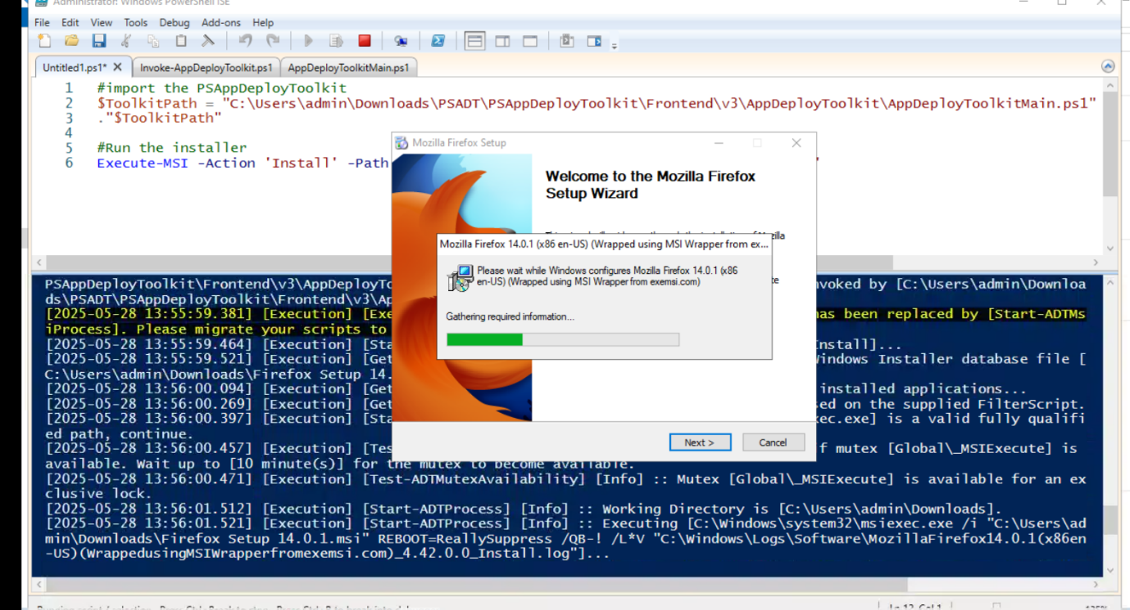

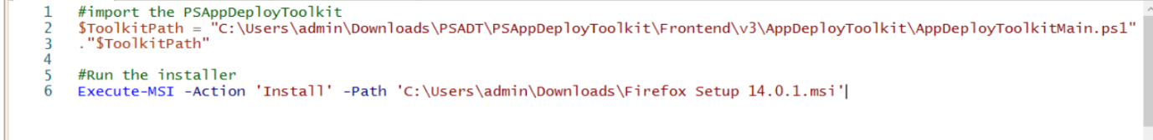

**Execute, Copy, Install and Active Setup Commands**

**List of commands:**

1. **Execute-MSI**

Executes msiexec.exe to perform the following actions for MSI & MSP files and we can install, uninstall, update etc as per the parameter -Action.

* Execute-MSI -Action 'Install' -Path 'Adobe_FlashPlayer_11.2.202.233_x64_EN.msi'
* Execute-MSI -Action 'Install' -Path 'Adobe_FlashPlayer_11.2.202.233_x64_EN.msi' -Transform 'Adobe_FlashPlayer_11.2.202.233_x64_EN_01.mst' -Parameters '/QN'
* Execute-MSI -Action 'Uninstall' -Path '{26923b43-4d38-484f-9b9e-de460746276c}'
* Execute-MSI -Action 'Patch' -Path 'Adobe_Reader_11.0.3_EN.msp'
* Execute-MSI -Action Install -Path $AppMSIName -SkipMSIAlreadyInstalledCheck -ContinueOnError $False -LogName "${AppMSIName}_MSI"

1. **Execute-Process**

Execute a process with optional arguments, working directory, window style.

* Execute-Process -Path 'uninstall_flash_player_64bit.exe' -Parameters '/uninstall' -WindowStyle 'Hidden'
* Execute-Process -Path "$dirFiles\Bin\setup.exe" -Parameters '/S' -WindowStyle 'Hidden'
* Execute-Process -Path 'setup.exe' -Parameters '/S' -IgnoreExitCodes '1,2'
* Execute-Process -Path 'setup.exe' -Parameters "-s -f2`"$configToolkitLogDir\$installName.log`""
* Execute-Process -Path 'setup.exe' -Parameters "/s /v`"ALLUSERS=1 /qn /L* `"$configToolkitLogDir\$installName.log`"`""

1. **Execute-MSP**

Reads SummaryInfo targeted product codes in MSP file and determines if the MSP file applies to any installed products.

* Execute-MSP -Path 'Adobe_Reader_11.0.3_EN.msp'
* Execute-MSP -Path 'AcroRdr2017Upd1701130143_MUI.msp' -AddParameters 'ALLUSERS=1'

1. **Copy-File**

Copy a file or group of files to a destination path.

* Copy-File -Path "$dirSupportFiles\*.*" -Destination "$envTemp\tempfiles"
* Copy-File -Path "$dirSupportFiles\MyApp.ini" -Destination "$envWinDir\MyApp.ini"

1. **Install-MSUpdate**

Install all Microsoft Updates of type ".exe", ".msu", or ".msp" in a given directory.

* Install-MSUpdates -Directory "$dirFiles\MSUpdates"

1. **Set-ActiveSetup**

Creates an Active Setup entry in the registry to execute a file for each user upon login.

* Set-ActiveSetup -StubExePath 'C:\Users\Public\Company\ProgramUserConfig.vbs' -Arguments '/Silent' -Description 'Program User Config' -Key 'ProgramUserConfig' -Locale 'en'
* Set-ActiveSetup -StubExePath "$envWinDir\regedit.exe" -Arguments "/S `"%SystemDrive%\Program Files (x86)\PS App Deploy\PSAppDeployHKCUSettings.reg`"" -Description 'PS App Deploy Config' -Key 'PS_App_Deploy_Config' -ContinueOnError $true